 |  | 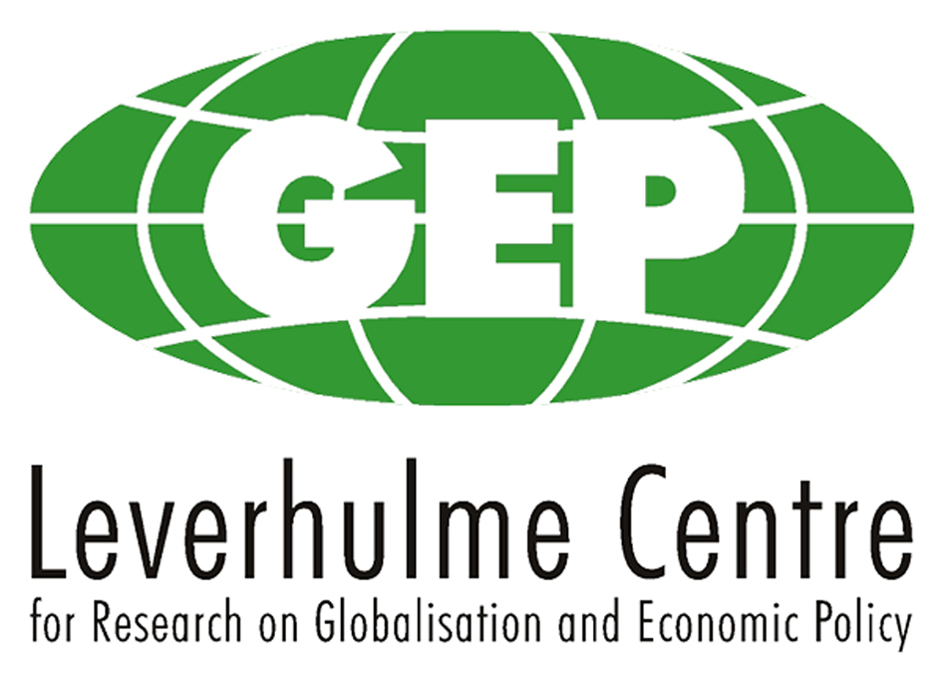

Zhejiang University, College of Economics
and
Leverhulme Centre for Globalisation and Economic Policy (GEP)
Joint Workshop

‘Trade Costs, Economic Geography and Firm Heterogeneity’

18th May 2011

Programme

Venue: Room 418, College of Economics, Zhejiang University, Hangzhou, China

9:00-9:20: Welcoming address by Professor Xiangrong Jin, Head of college of economics, Zhejiang University;
Few words by Head of Nottingham School of Economics, Professor Chris Milner

Session 1: Chair – Professor Shiyuan Pan

9:20-9:50: ‘Trade Costs and Trade Composition’
Professor Chris Milner, GEP, University of Nottingham

9:50-10:20: ‘Market Size, Negative Demand Shock, and International Vertical Mergers’
Dr Jie Li, College of Economics, Zhejiang University

10:20 -10:40 Tea/Coffee break

Session 2: Chair – Professor Daniel Bernhofen

10:40-11:10: ‘The role of economic geographic factors with spatial elements in the location decision of multinationals in Chinese Cities’
Dr Saileshsingh Gunessee (with Dr Chang Liu), GEP, University of Nottingham, Ningbo

11:10-11:40: ‘Comparative Advantage and Multi-product Firms’
Dr Huasheng Song, College of Economics, Zhejiang University

12:00-13:30: Lunch

Session 3: Chair – Professor Chris Milner

13:30-14:00: ‘Patent Protection in a Model with Heterogeneous Firms’
Professor Shiyuan Pan, College of Economics, Zhejiang University

14:00-14:30: ‘Containerization and international trade’
Professor Daniel Bernhofen, Director of GEP, University of Nottingham

14:30-14:40: Concluding remarks (Professor Xianhai Huang and Professor Daniel Bernhofen)

14:40-16:00: Tour of Campus

18:00- Dinner

